
Founded by: Mir Khalil-ur-Rahman

http://www.thenews.com.pk/Todays-News-7-237550-Govt-civil-society-and-media-urged-to-join-hands-against-corruption

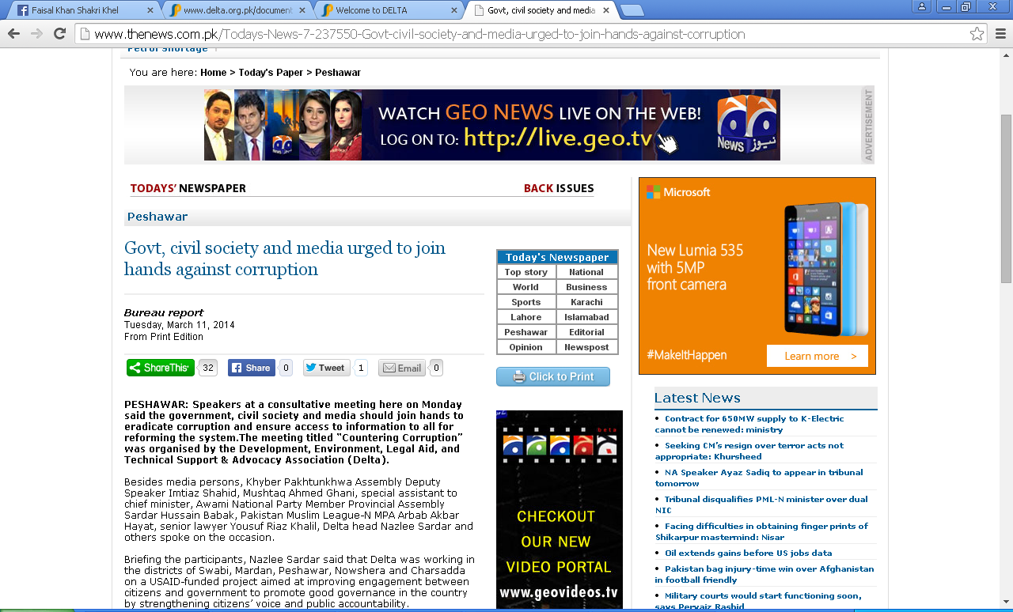

PESHAWAR: Speakers at a consultative meeting here on Monday said the government, civil society and media should join hands to eradicate corruption and ensure access to information to all for reforming the system. The meeting titled “Countering Corruption” was organized by the Development, Environment, Legal Aid, and Technical Support & Advocacy Association (Delta).

Besides media persons, Khyber Pakhtunkhwa Assembly Deputy Speaker Imtiaz Shahid, Mushtaq Ahmed Ghani, special assistant to chief minister, Awami National Party Member Provincial Assembly Sardar Hussain Babak, Pakistan Muslim League-N MPA Arbab Akbar Hayat, senior lawyer Yousuf Riaz Khalil, Delta head Nazlee Sardar and others spoke on the occasion.

Briefing the participants, Nazlee Sardar said that Delta was working in the districts of Swabi, Mardan, Peshawar, Nowshera and Charsadda on a USAID-funded project aimed at improving engagement between citizens and government to promote good governance in the country by strengthening citizens’ voice and public accountability.

She said that charter of demands had been prepared by the organization and presented to the provincial government in 2013 where some of the demands were already met by the PTI-led government like passing legislation on Right to Information, to enable citizens to access information, replacing anti-corruption establishment, a toothless body with Ehtesab Cell; replacing ACE’s grade-18 officer who could not check corruption by his superiors in 19–22 grades, with a commissioner having more powers.

Naazlee Sardar, however, lamented that reports were circulating about how the PTI government was indulging in corruption, saying that the chief minister’s Citizens Complaint Cell (CCC) was located between the Governor’s House and CM’s House. How many citizens can access it, she asked.

Yousaf Riaz Khalil, a lawyer of the high court, presented recommendations for countering corruption, and said citizens can use the RTI to eliminate corruption by demanding information from the government Mushtaq Ahmed Ghani said corruption had gained roots in our society. Zareen Zia, PTI MPA and Arbab Akbar Hayat, a lawmaker from the PML-N also addressed.

http://akhbarekhyber.com/newspaper/large/newspaper_image_2014-03-11_13452.jpg

